Laporan Praktikum DB MySql

1. Permasalahan 1
   1. Database lat_mysql



* 1. Tabel nama pegawai

* 1. Isi tabel

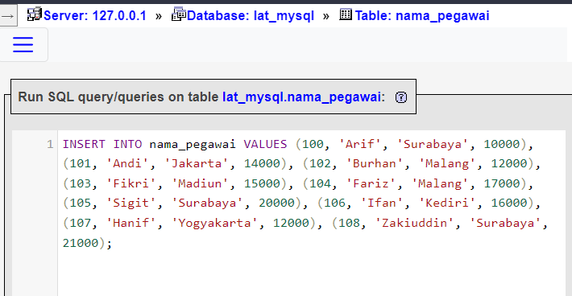

* 1. Hapus ID 100

* 1. Update data 101 dan 102

* 1. Perintah-perintah SQL untuk menampilkan:
     1. Seluruh isi tabel pegawai

* + 1. Kolom nama dan gaji dari tabel pegawai

* + 1. Kolom nama dan alamat yang mempunyai nama berawalan F

* + 1. Kolom nama dan alamat yang mempunyai nama berakhiran n

* + 1. Kolom nama dan gaji yang mempunyai gaji di atas 15000

* + 1. Kolom nama, alamat dan gaji yang bergaji di atas 13000 dan beralamat di Surabaya

* + 1. Kolom nama, gaji dengan range gaai di antara 15000-20000

* + 1. Gaji max, min, rata-rata dari tabel pegawai

1. Permasalahan 2
   1. 2 tabel pegawai dan departemen yang berhubungan

* 1. Isi data 2 tabel



* 1. Buat perintah SQL:
     1. Tampilkan nama pegawai , alamat dan nama dep

* + 1. Tampilkan id pegawai, nama dan nama dep

